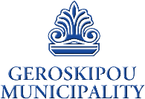
Documentation for a civil wedding in Geroskipou

ISRAELI CITIZENS

Regarding your civil marriage in Geroskipou, please note that you will be requested for the following documents:

1. Single Affidavit from the Ministry of Interior in Israel (Blue Paper).

2. Valid Passport.

3. Change of Name (if applicable).

PLEASE NOTE:

All the above documents must be original documents officially translated into English and are valid ONLY for three (3) months. Documents must also be legalized in the country of origin by carrying an APOSTILLE stamp.

